**Getting Started with GitHub for Connected Bradford**

This guide is designed to help Analysts and other users unfamiliar with GitHub navigate the Connected Bradford GitHub page. It will cover key functionalities such as accessing the repository, understanding its structure, uploading documents, and collaborating effectively.

**1. Accessing the Connected Bradford GitHub Page**

**1. Visit the GitHub Page:** Open a web browser and go to the [Connected Bradford GitHub page]( [Connected Bradford](https://github.com/ConnectedBradford)).

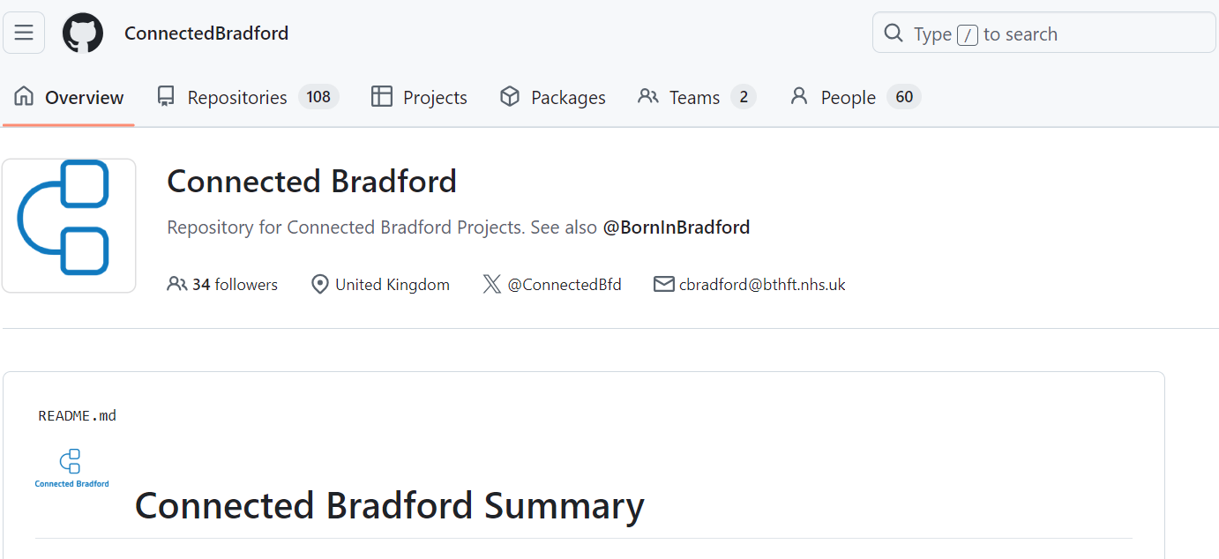

**2. Create an Account (if needed):** If you don’t already have a GitHub account:

- Go to [github.com](https://github.com) and click on Sign Up.

- Follow the instructions to create your account.

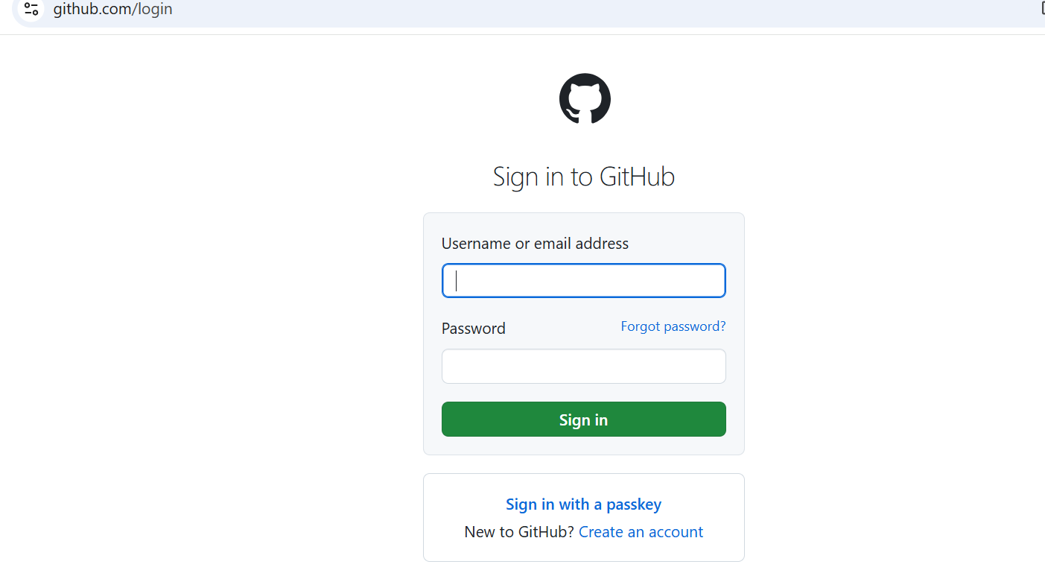

**3. Request Access:** If the repository is private, contact the repository administrator to gain access. Provide your GitHub username for approval. Please send your Githib username to [cbradford@bthft.nhs.uk](mailto:cbradford@bthft.nhs.uk) , we will add you to our team for access to the private folders.

**2. Navigating the GitHub Repository**

**Key Components:**

**- Code Tab:** View the repository’s files and folder structure.

**- Issues Tab:** Report or track project-related tasks and problems.

**- Pull Requests Tab:** Collaborate by proposing changes to the repository.

**- Wiki Tab:** Access documentation or guides related to the project.

**- Projects Tab:** Visualize project boards and task progress.

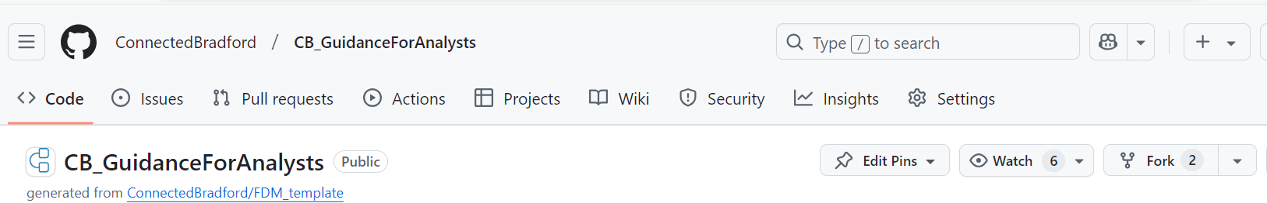

**Repository Structure:**

**The Connected Bradford repository is organized as follows:**

- **Data Summary:** A summary of the data available in the repository.

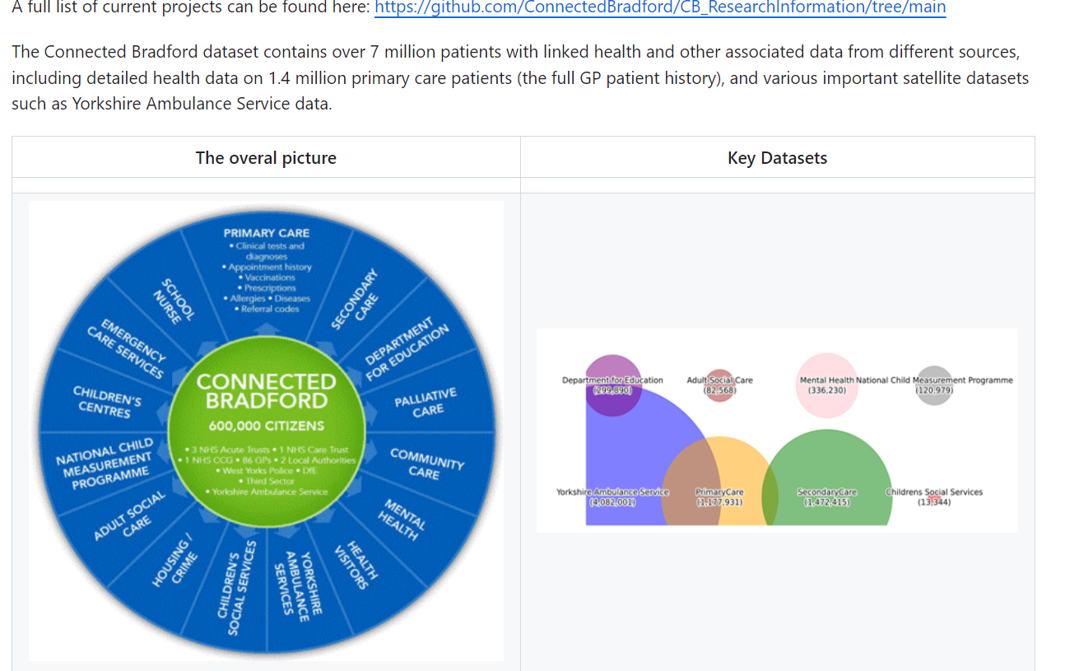

- **"Wheel of Data" Diagram:** This visual representation illustrates the range of data sources and how they correspond to specific datasets.

- **Folders:** Organized by data type or project component (e.g., `Cardiovascular Data`, `Respiratory Data`).

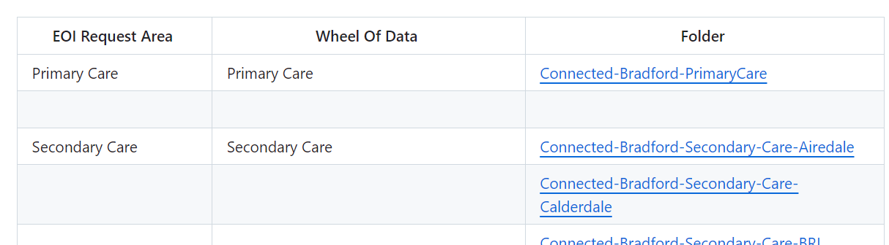

**3. Downloading Files from GitHub**

1. **Navigate to the File:** Browse the repository to locate the file you need.

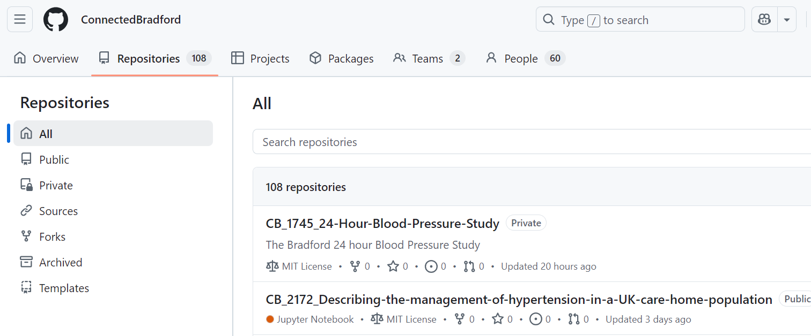

2. **Download the File:**

- Click on the file to open it.

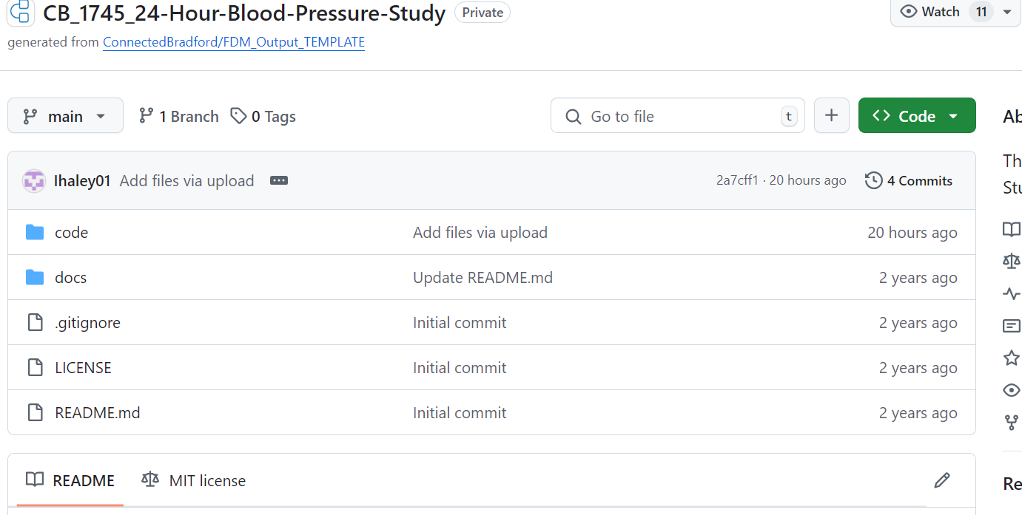

- Click the Download button or select the Raw option and save the file.

3. **Clone the Repository (Optional):**

- Copy the repository URL: git clone <repository-url>

* To clone the repository using HTTPS, under "HTTPS", click file.
* To clone the repository using an SSH key, including a certificate issued by your organization's SSH certificate authority, click SSH, then click file .

To clone a repository using GitHub CLI, click GitHub CLI, then click copy.

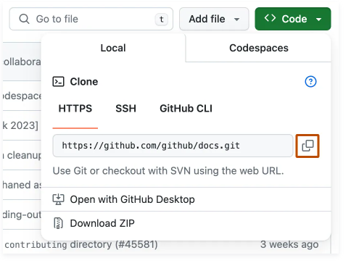

* Open Git Bash.
* Change the current working directory to the location where you want the cloned directory.
* Type git clone, and then paste the URL you copied earlier.



* Press Enter to create your local clone.

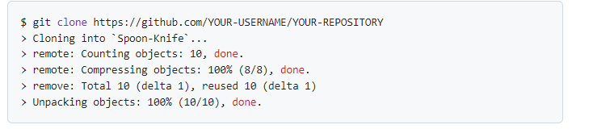

**4. Uploading Documents to GitHub**

**Using the GitHub Web Interface**:

1. **Navigate to the Repository:** Open the Connected Bradford repository.

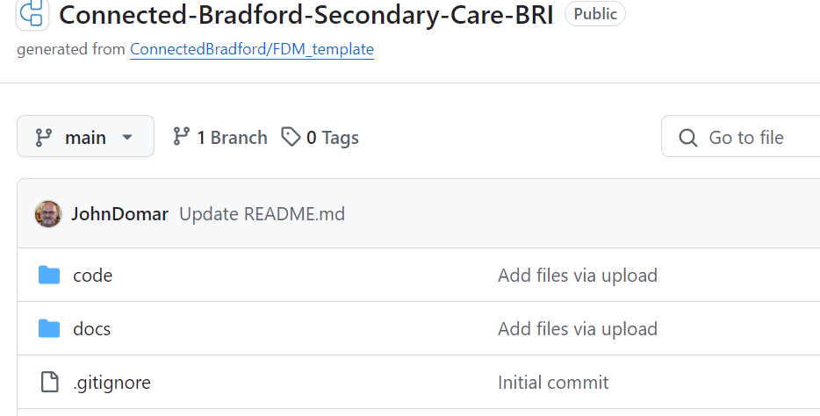

**2. Add Files:**

- Click on Add file > Upload files.



- Drag and drop the files or use the file picker.

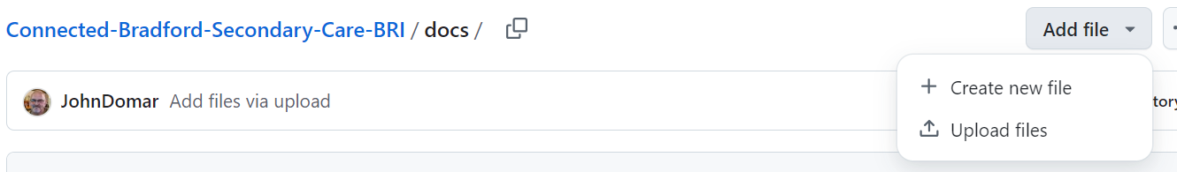

**3. Commit Changes**:

- Provide a meaningful commit message (e.g., "Added new respiratory dataset").

- Select the branch you want to commit to (e.g., `main` or a specific feature branch).

- Click Commit changes.

**Using GitHub Desktop:**

1. Download GitHub Desktop: Install it from [desktop.github.com](https://desktop.github.com).

**2. Clone the Repository:**

- Open GitHub Desktop.

- Select File > Clone Repository, then choose the Connected Bradford repository.

**3. Add Files Locally:** Copy the files to the repository folder on your computer.

4. **Commit and Push Changes:**

- In GitHub Desktop, write a commit message and click Commit to main.

- Click Push origin to upload changes to GitHub.

**5. Collaborating on GitHub**

**Creating Issues:**

1. Go to the Issues tab.

2. Click New Issue.

3. Add a title, description, and any relevant labels or assignees.

4. Click Submit new issue.

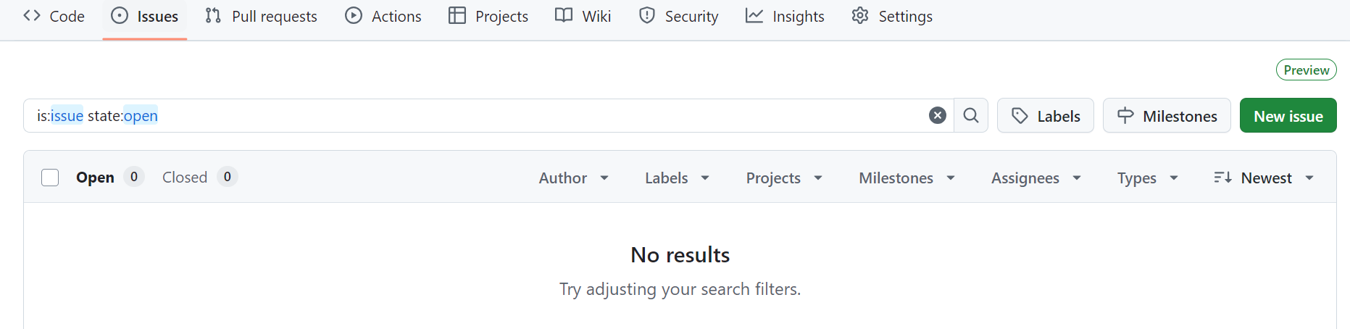

**Making Changes:**

**1. Create a Branch:**

- In the repository, click Branch: main > New branch.

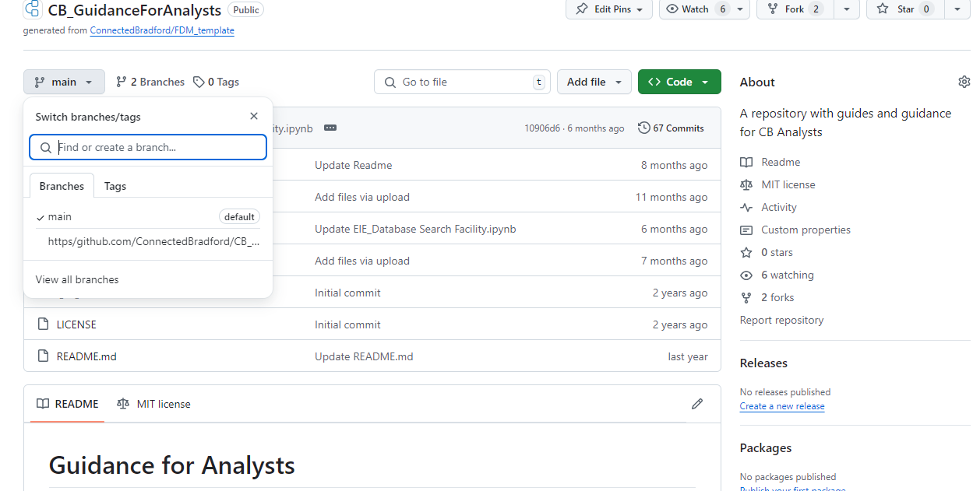

- Name your branch descriptively (e.g., `update-data-summary`).

2. **Edit Files:** Make changes to files directly on GitHub or locally.

3. **Open a Pull Request**:

- Go to the **Pull Requests** tab and click **New Pull Request**.

- Select your branch and describe your changes.

- Click Create Pull Request.

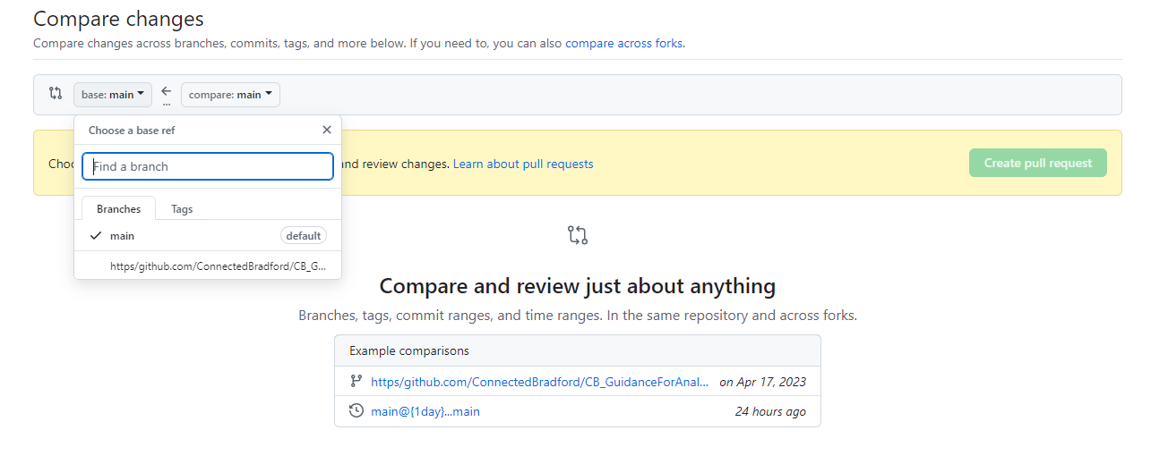

**Reviewing and Merging:**

1. Review pull requests in the **Pull Requests** tab.

2. Approve or request changes.

3. Merge the pull request when approved.

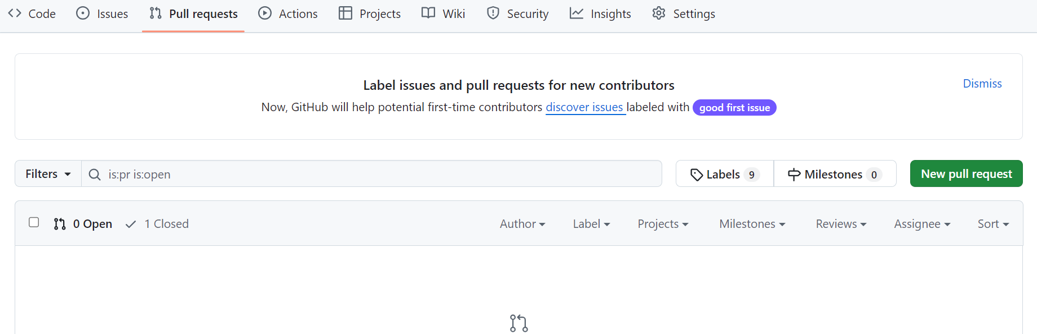

**6. Best Practices**

- **Use Meaningful Commit Messages:** Clearly describe the changes made in each commit.

- **Follow Repository Structure:** Place files in the correct folder to maintain organization.

- **Collaborate Effectively:** Use issues and pull requests to discuss and track changes.

- **Respect Data Privacy:** Ensure sensitive data is anonymized and complies with data protection regulations before uploading.

In addition to the previously discussed features, the Connected Bradford GitHub page offers several other resources that analysts and users should be aware of:

**1. Flexible Data Models (FDMs):**

- Connected Bradford employs Flexible Data Models to standardize and structure diverse datasets, facilitating efficient analysis and integration.

- Each dataset, such as Primary Care, Autism, and Adult Social Care, has its own repository containing scripts, data dictionaries, and documentation.

- For example, the [Connected Bradford Primary Care repository]( [Connected-Bradford-PrimaryCare](https://github.com/ConnectedBradford/Connected-Bradford-PrimaryCare)) includes approximately 1 million anonymized patient records, along with the necessary tools for data utilization.

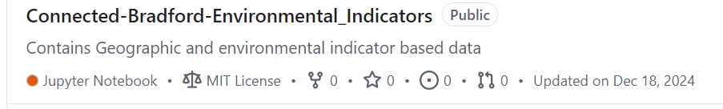

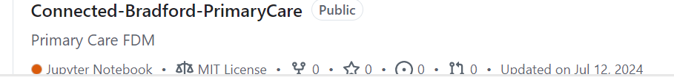

**2. Project-Specific Repositories:**

- Each research project is assigned a unique reference number and a corresponding GitHub repository named in the format "CB_nnnn - description."

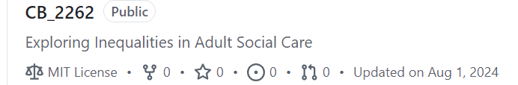

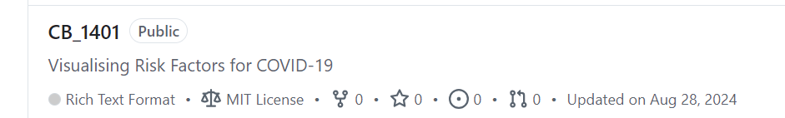

- These repositories store the code and outputs related to specific research endeavours, ensuring organized and accessible project documentation.

**3. Data Dictionaries:**

- Comprehensive data dictionaries are available within each dataset's repository, detailing table structures, field types, and sample data values.

- These dictionaries assist analysts in understanding the dataset contents and facilitate accurate data interpretation.

4. Environmental Indicators:

- The [Connected Bradford Environmental Indicators repository]( [Connected-Bradford-Environmental_Indicators](https://github.com/ConnectedBradford/Connected-Bradford-Environmental_Indicators)) contains geographic and environmental data tables, such as daily air quality metrics across the Bradford district.

- This information supports research into environmental factors affecting public health.

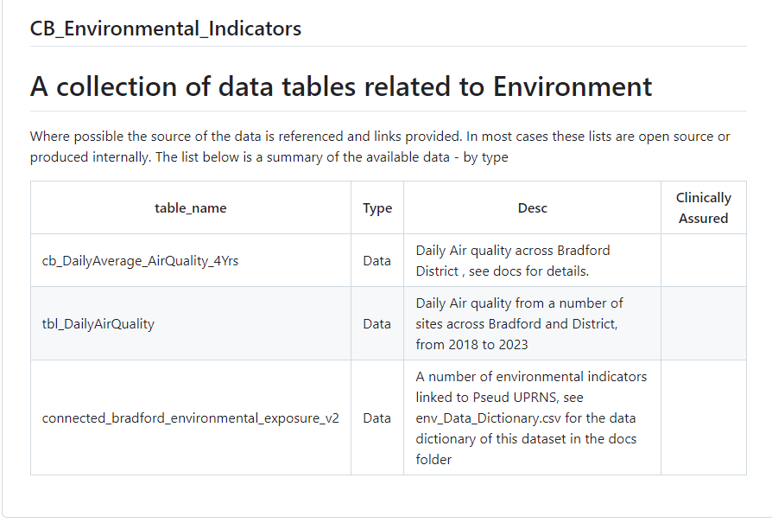

**Example fdm project folders include:**

**5. National Child Measurement Programme (NCMP):**

- The [Connected Bradford NCMP repository]([Connected-Bradford-NationalChildMeasurementProgramme](https://github.com/ConnectedBradford/Connected-Bradford-NationalChildMeasurementProgramme)) provides data on approximately 120,000 children, including summaries, data dictionaries, and relevant code.

- This dataset is crucial for studies related to child health and development.

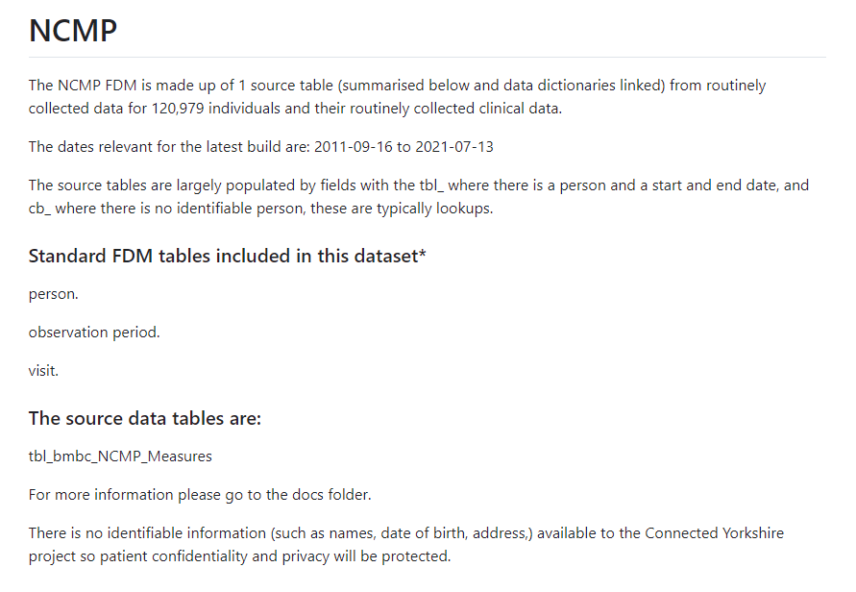

**6. Yorkshire Ambulance Service (YAS) Data:**

-The [Connected Bradford YAS repository]( [Connected-Bradford-YorkshireAmbulanceService](https://github.com/ConnectedBradford/Connected-Bradford-YorkshireAmbulanceService)) offers summaries, data dictionaries, and code related to ambulance service data.

- This dataset enables analysis of emergency medical services and patient outcomes.

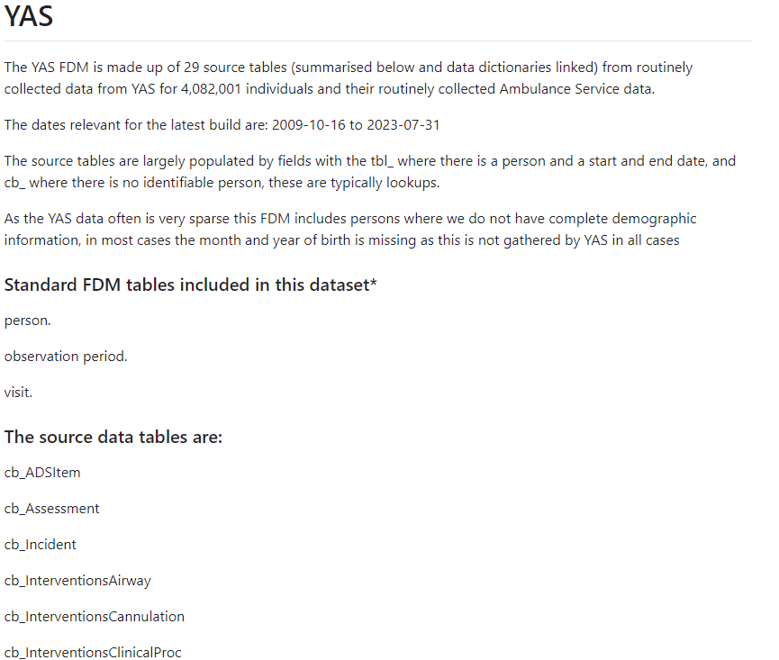

**7. Additional Resources**

- [GitHub Documentation](https://docs.github.com): Comprehensive guides for using GitHub.

- [Markdown Guide](https://www.markdownguide.org): Learn how to format text on GitHub using Markdown.

- [Connected Bradford Team Contacts]: Reach out to the admin team for assistance.

By exploring these resources, analysts and users can effectively leverage the comprehensive data available through the Connected Bradford GitHub page for their research and analytical needs.